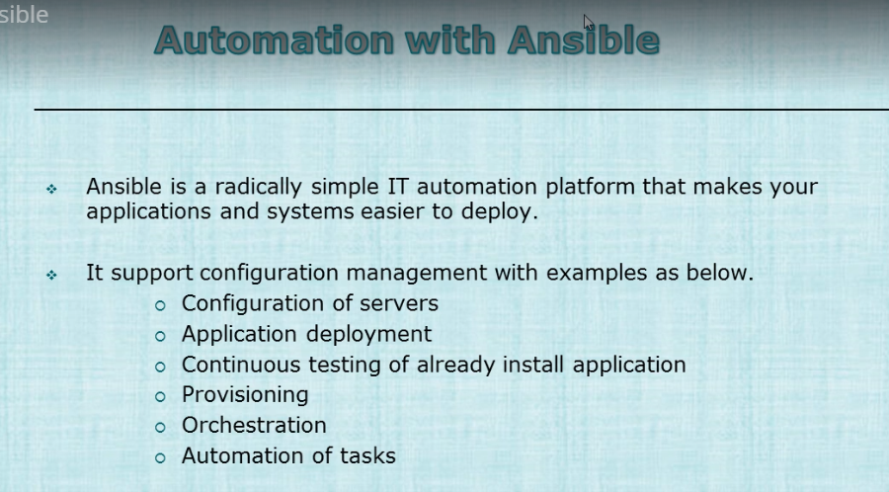

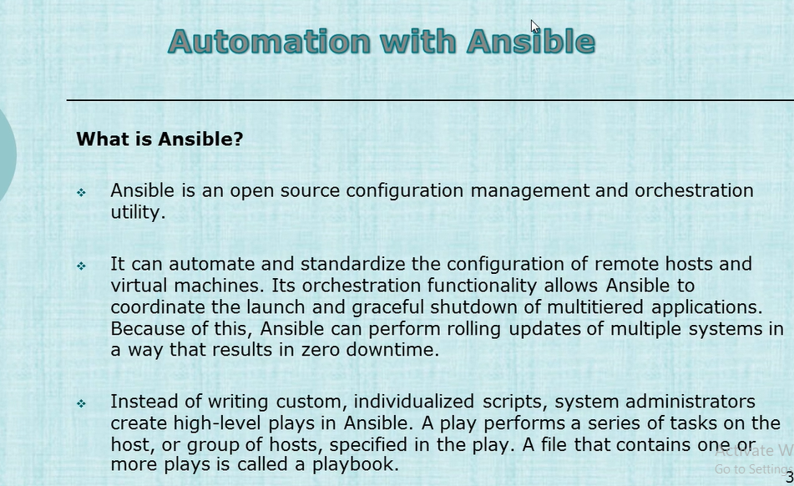







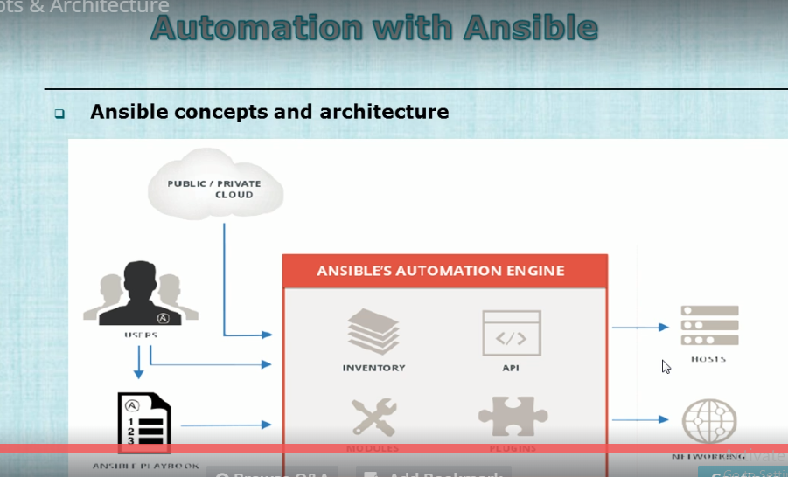

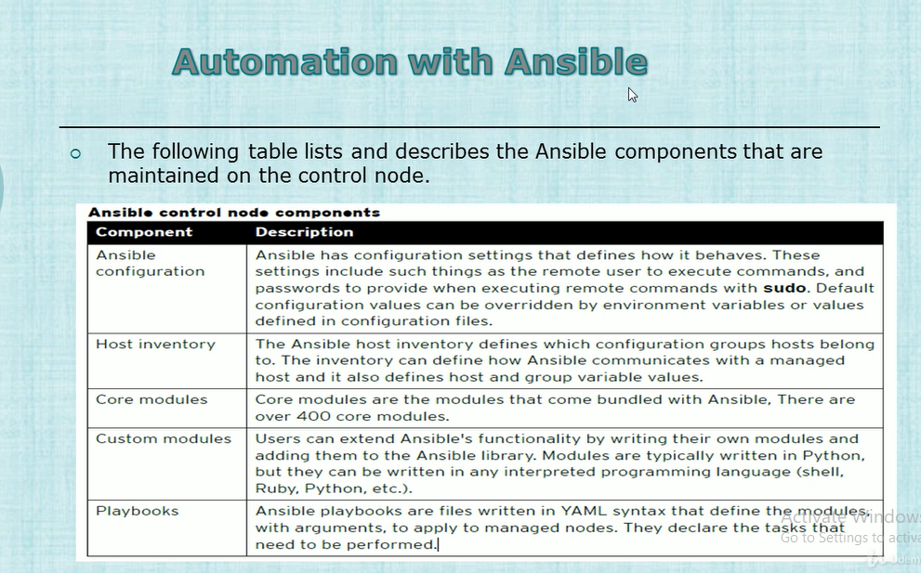

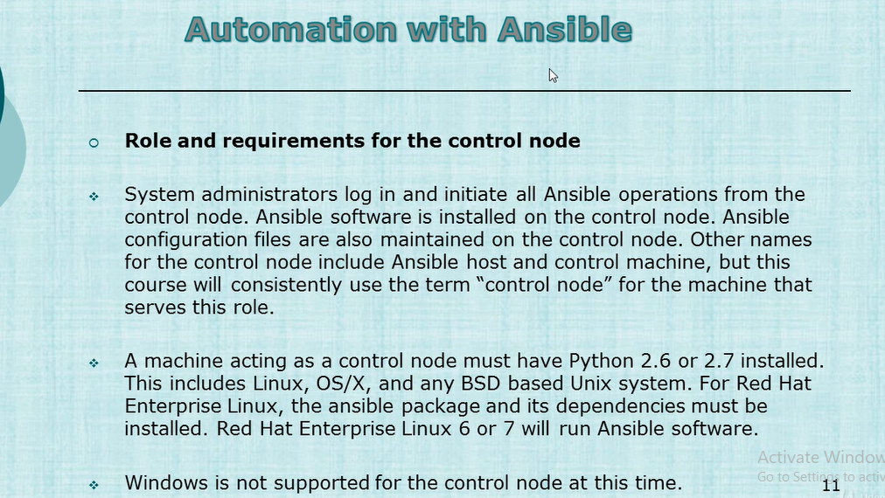

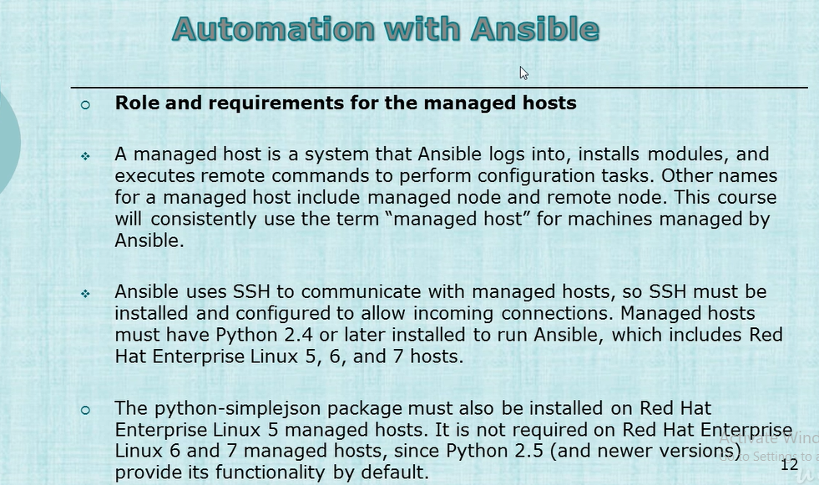

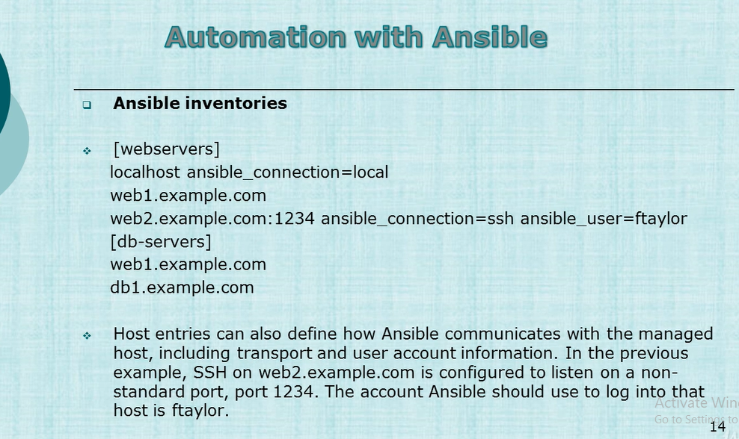

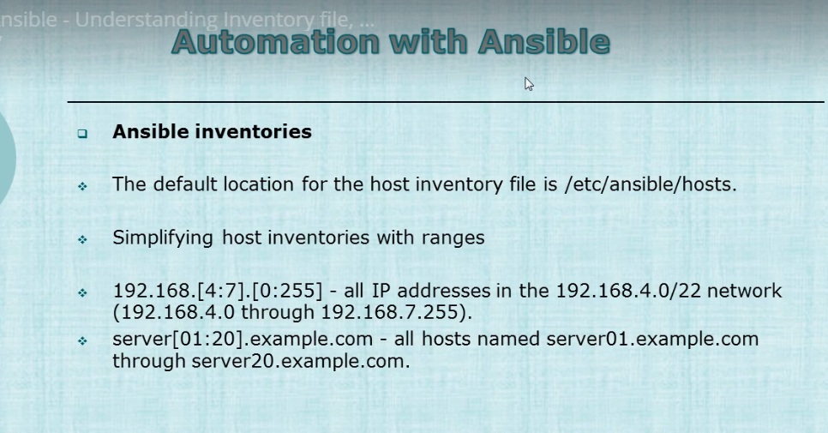

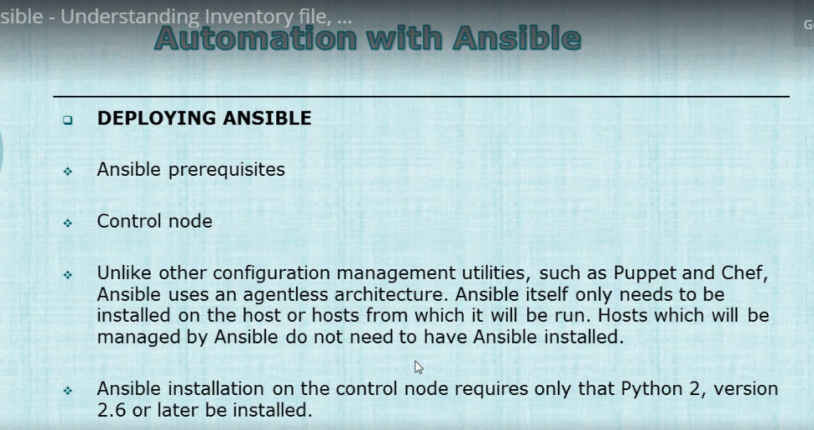

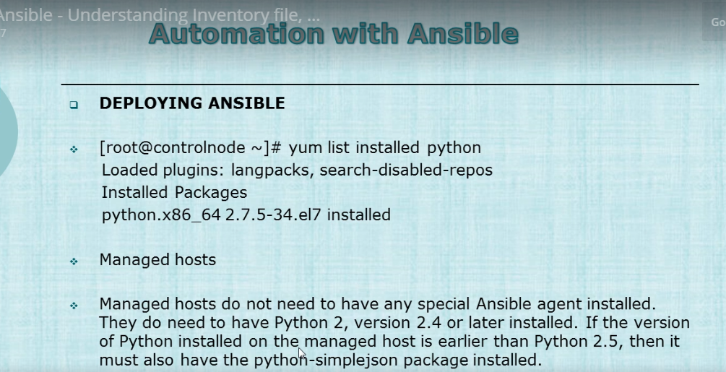

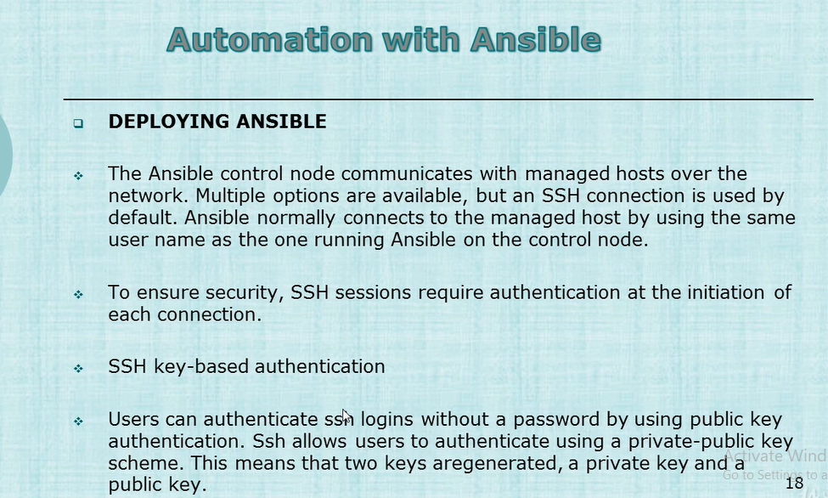

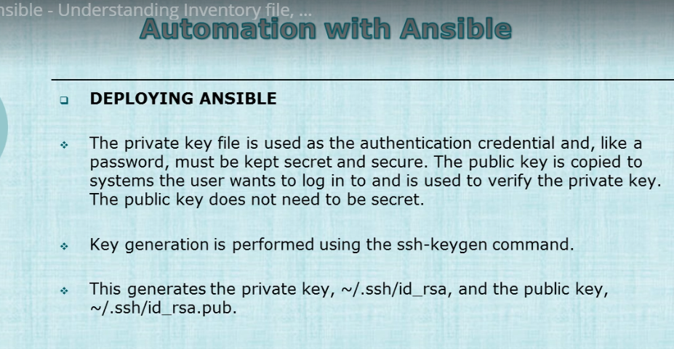

1 pwd

2 mkdir .ssh

3 cd .ssh/

4 cd ..

5 chmod 700 .ssh

6 chmod 700 .ssh/

7 cd .ssh/

8 scp -p 13.126.177.169://home/unixadmin/.ssh/id_rsa.pub authorized_keys

9 ll

10 history



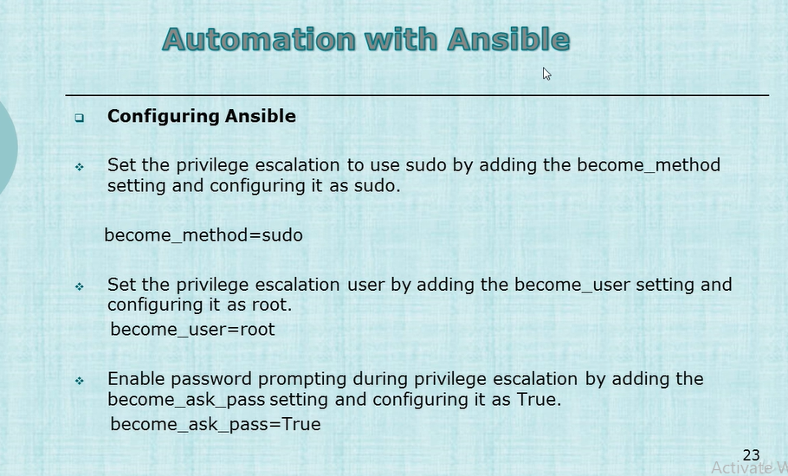

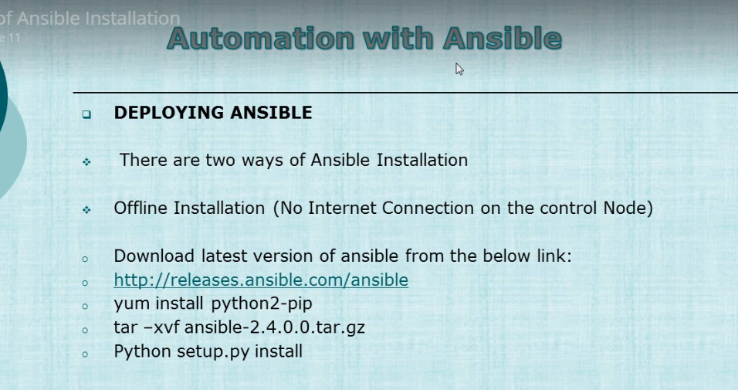

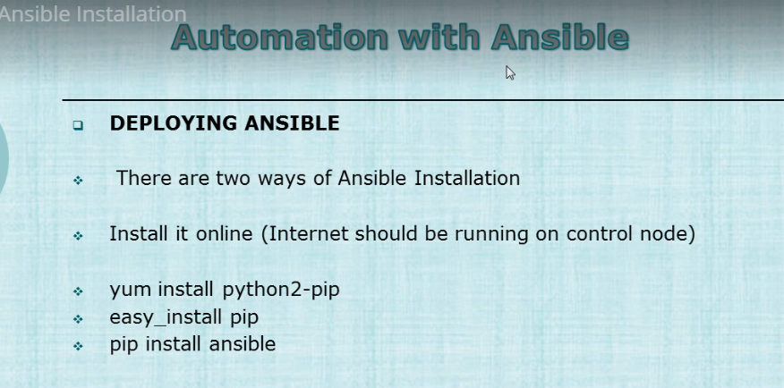

To install pip and wheel for the system Python, there are two options:

1. Enable the [EPEL repository](https://fedoraproject.org/wiki/EPEL) using [these instructions](https://fedoraproject.org/wiki/EPEL#How_can_I_use_these_extra_packages.3F). On EPEL 6 and EPEL7, you can install pip like so:
2. sudo yum install python-pip

On EPEL 7 (but not EPEL 6), you can install wheel like so:

sudo yum install python-wheel

Since EPEL only offers extra, non-conflicting packages, EPEL does not offer setuptools, since it’s in the core repository.

1. Enable the [PyPA Copr Repo](https://copr.fedoraproject.org/coprs/pypa/pypa/) using [these instructions](https://fedorahosted.org/copr/wiki/HowToEnableRepo) [[1]](https://packaging.python.org/guides/installing-using-linux-tools/#id4). You can install pip and wheel like so:
2. sudo yum install python-pip python-wheel

To additionally upgrade setuptools, run:

sudo yum upgrade python-setuptools

[pypa-pypa]

name=Copr repo for pypa owned by pypa

baseurl=https://copr-be.cloud.fedoraproject.org/results/pypa/pypa/epel-7-$basearch/

type=rpm-md

skip_if_unavailable=True

gpgcheck=1

gpgkey=https://copr-be.cloud.fedoraproject.org/results/pypa/pypa/pubkey.gpg

repo_gpgcheck=0

enabled=1

enabled_metadata=1

How to created password less authentication

ssh ansible@192.168.38.61 mkdir -p .ssh

cat .ssh/id_rsa.pub | ssh ansible@192.168.38.61 'cat >> .ssh/authorized_keys'

ssh ansible@192.168.38.61 "chmod 700 .ssh; chmod 640 .ssh/authorized_keys"

ssh [ansibleadmin@52.66.68.142](mailto:ansibleadmin@52.66.68.142)

when doing ssh into ubuntu then all files and folders should be owned by ansibleadmin within home directory

Make entry in

[ansibleadmin@server ~]$ cat /etc/ansible/hosts

[webserver]

13.127.58.87

[devel]

52.66.68.142

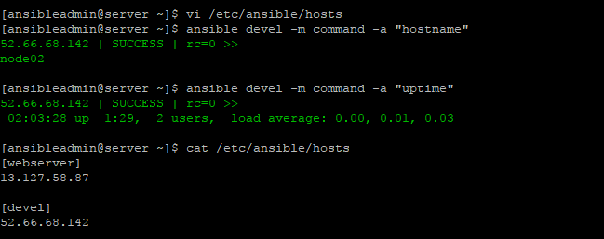

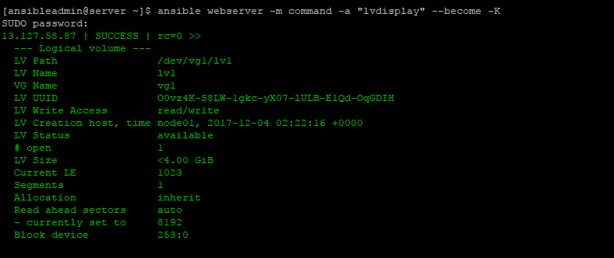

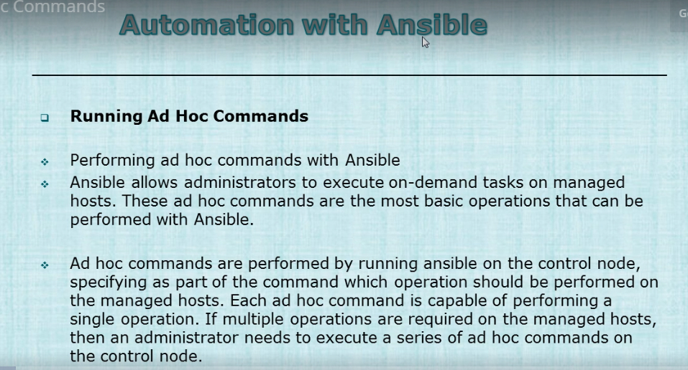

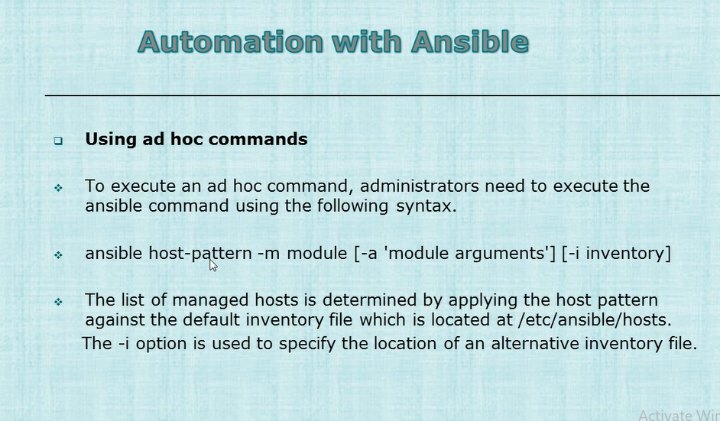

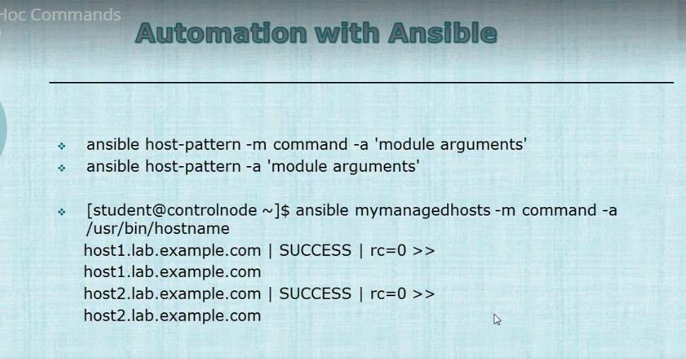

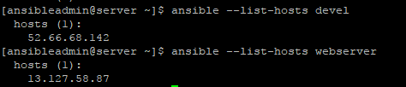

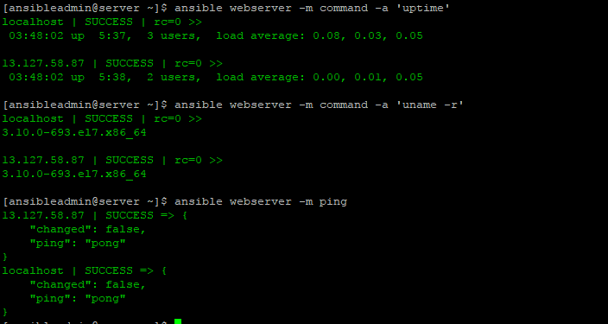

This will copy the files to devel nodes

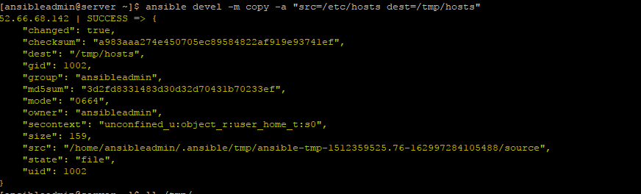

Running the above did not preserve the permission so will run with - -become

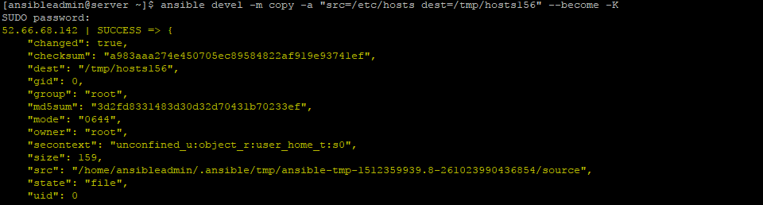

Now, changing the permission of the file.

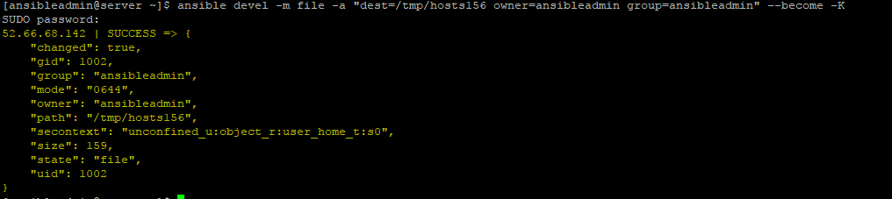

To delete a file

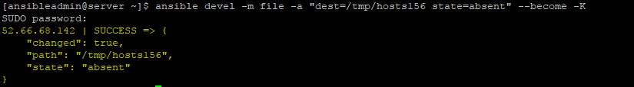

Normally the ansible.cfg is located at /etc/ansible/ansible.cfg

For my system it is

/usr/lib/python2.7/site-packages/ansible/galaxy/data/container_enabled/tests/ansible.cfg

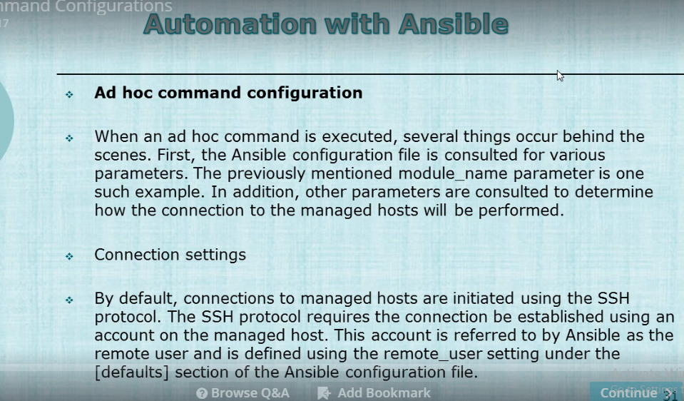

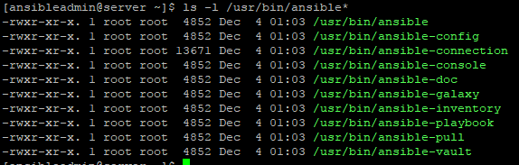

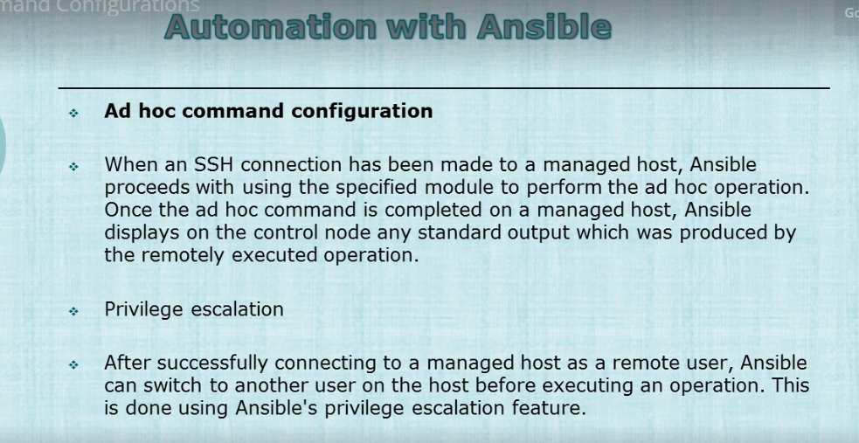





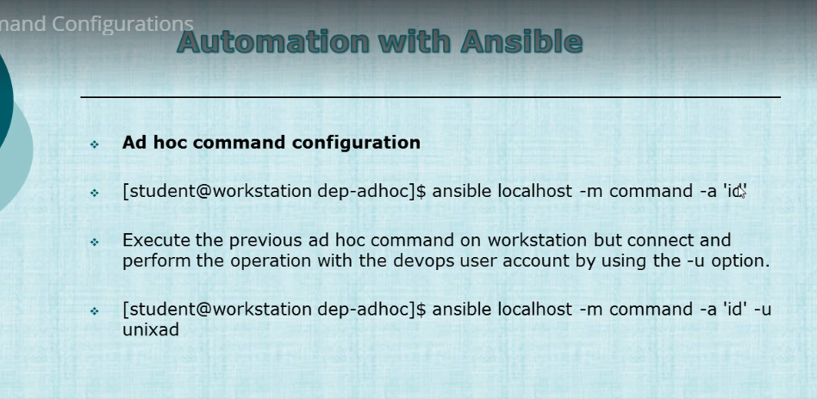

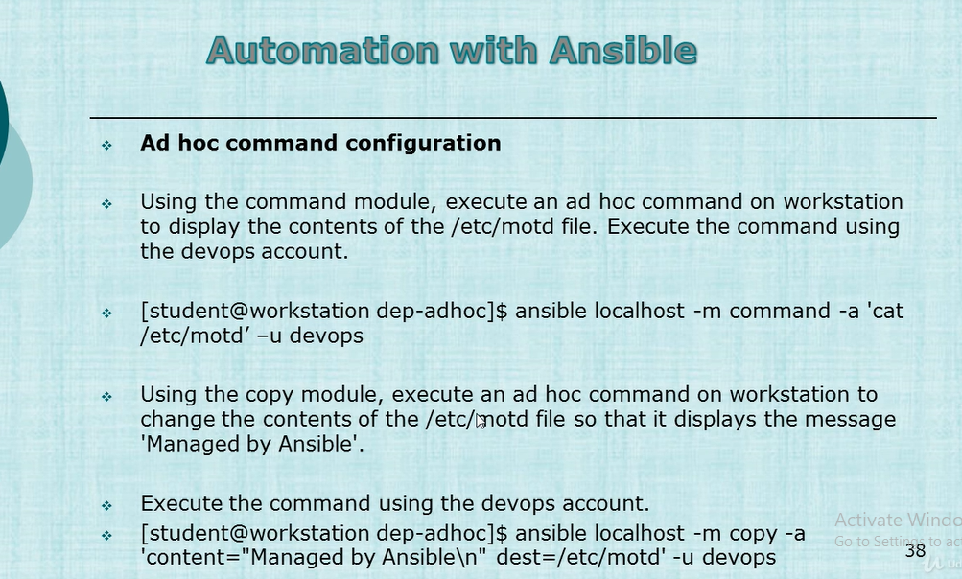

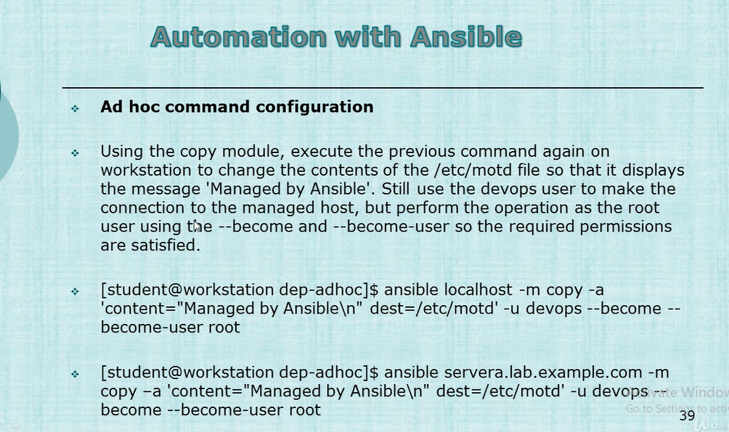

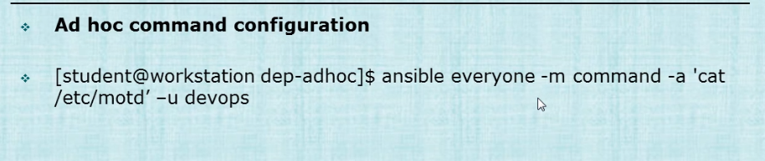

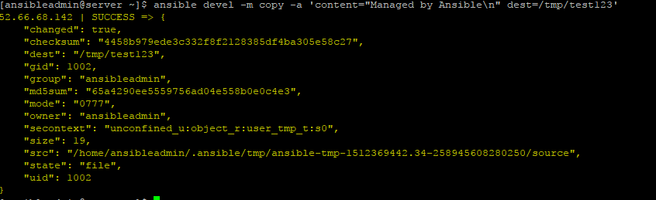



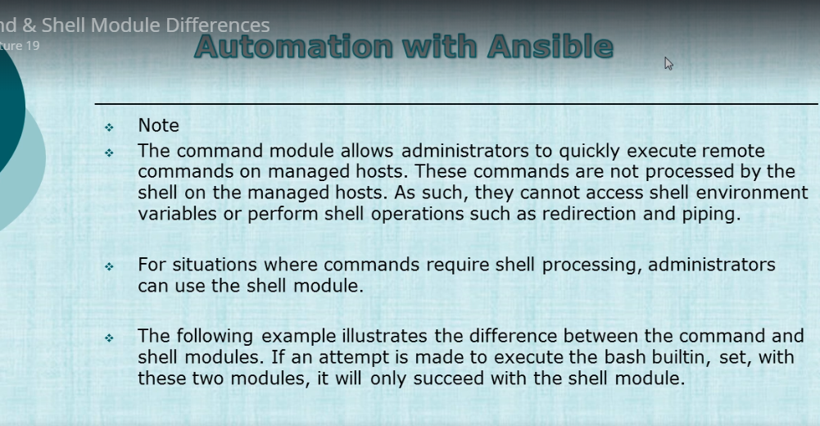

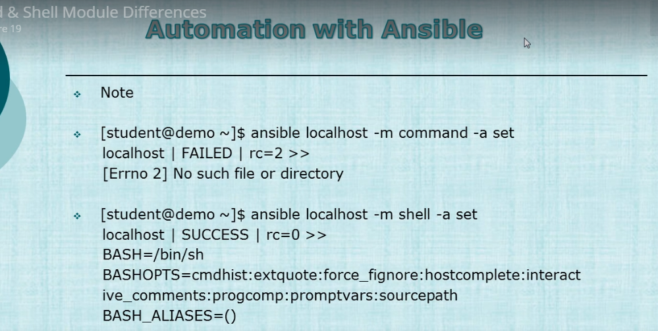

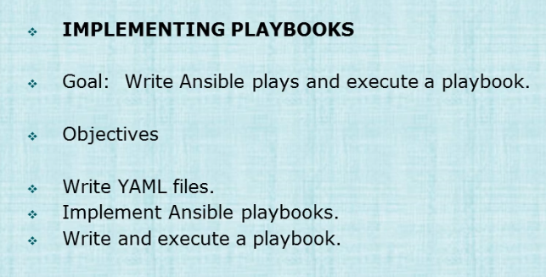

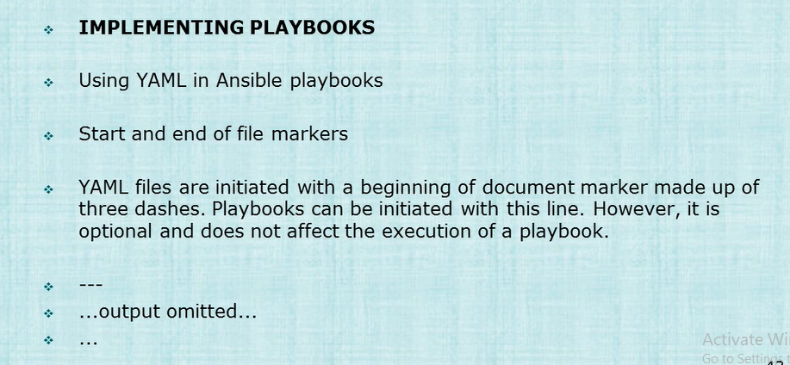

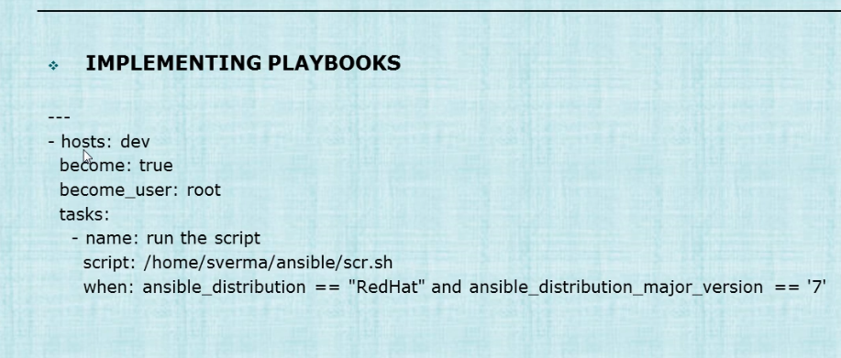

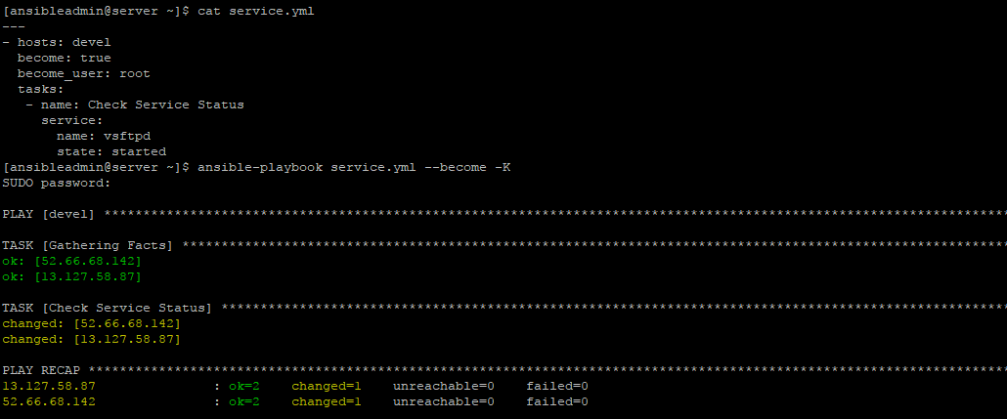

This will copy a file from control node to the hosts

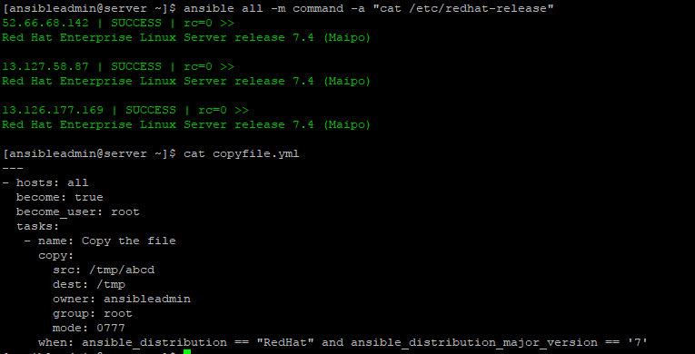

Modules in Ansible

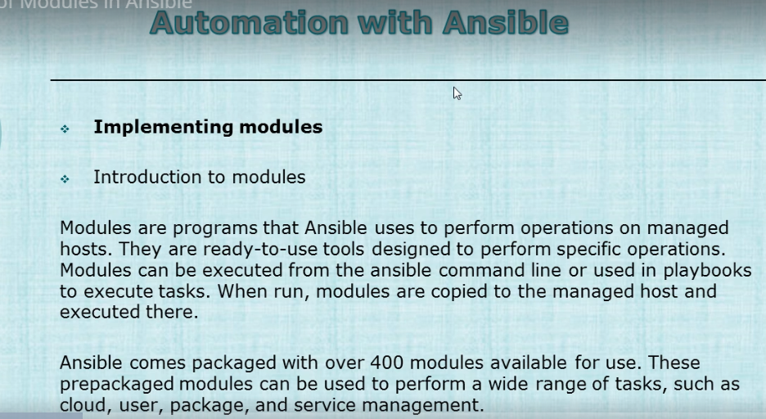

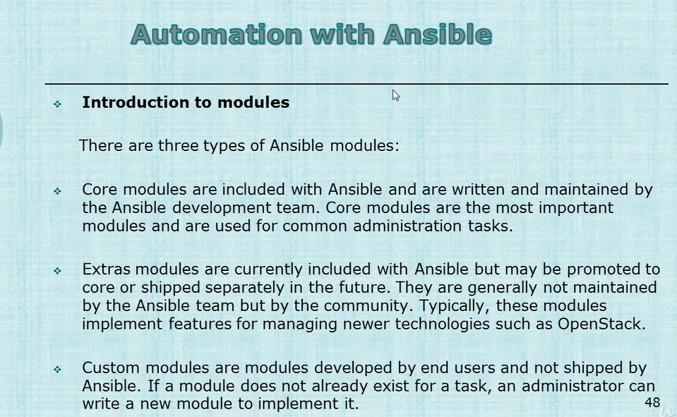

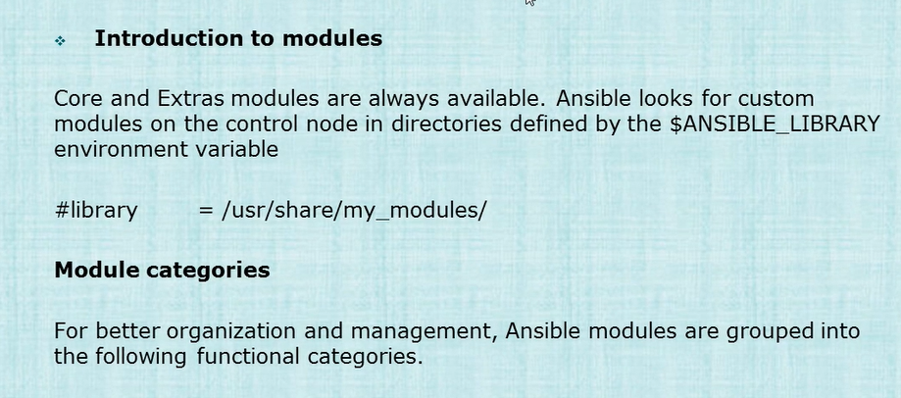

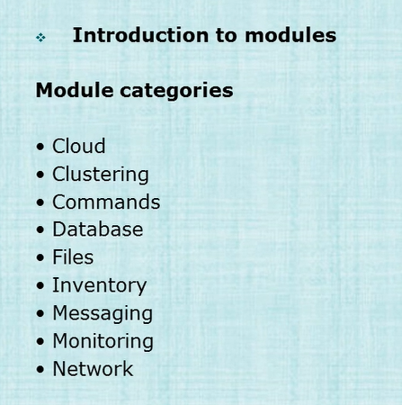

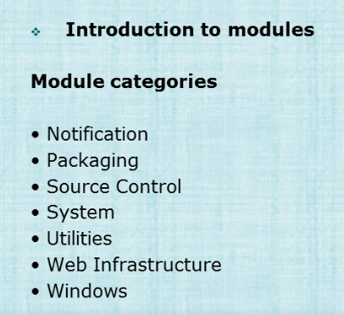

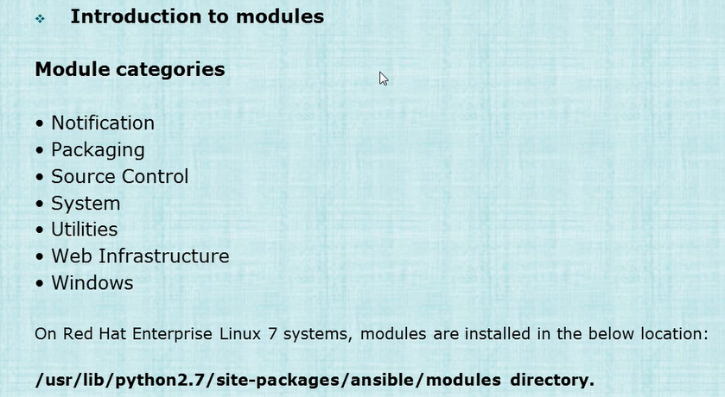

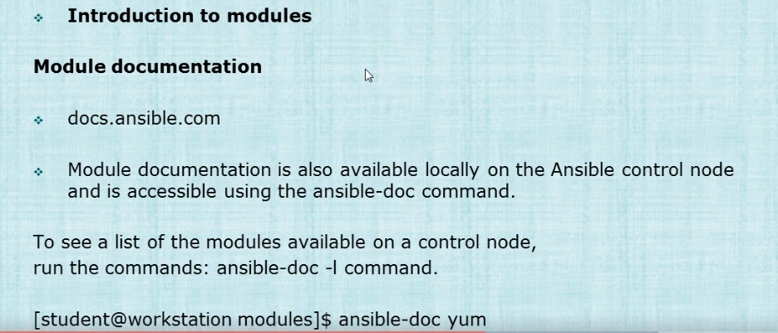

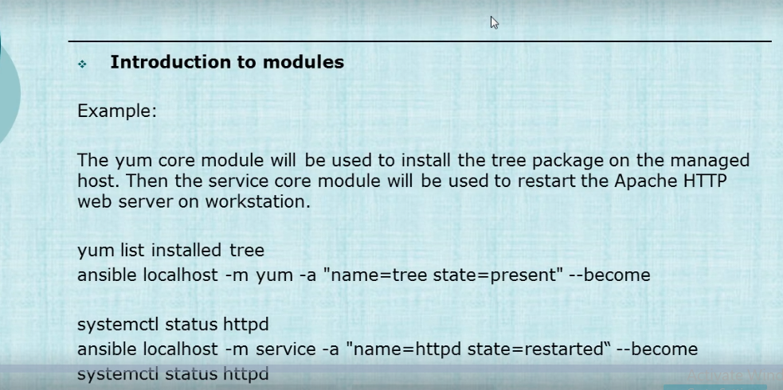

Installing latest tree package through yum

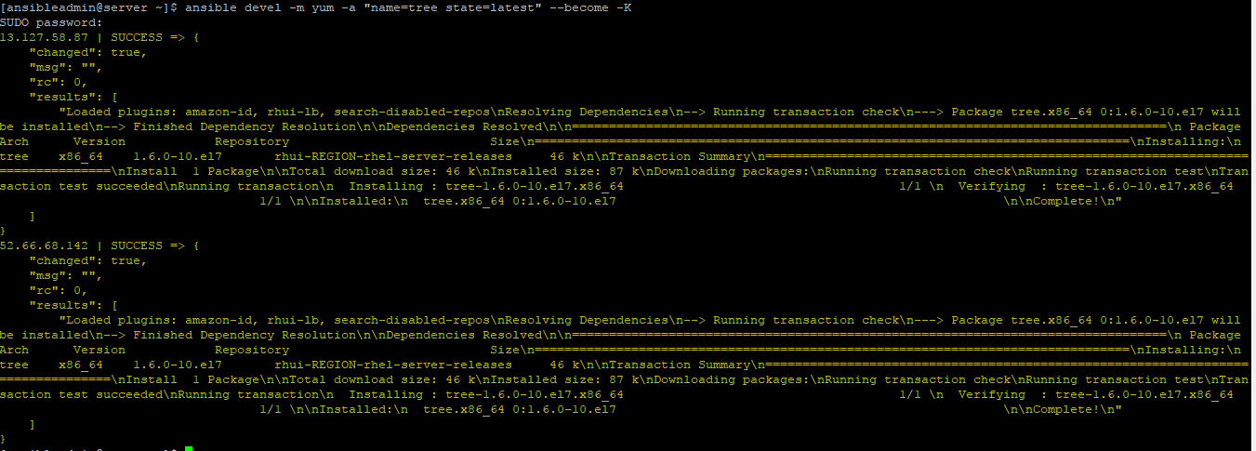

Command to ensure a service is running

[ansibleadmin@server ~]$ ansible 52.66.68.142 -m service -a "name=httpd state=started" --become -K

Command to enable the service at boot:-

[ansibleadmin@server ~]$ ansible 52.66.68.142 -m service -a "name=httpd enabled=yes" --become -K

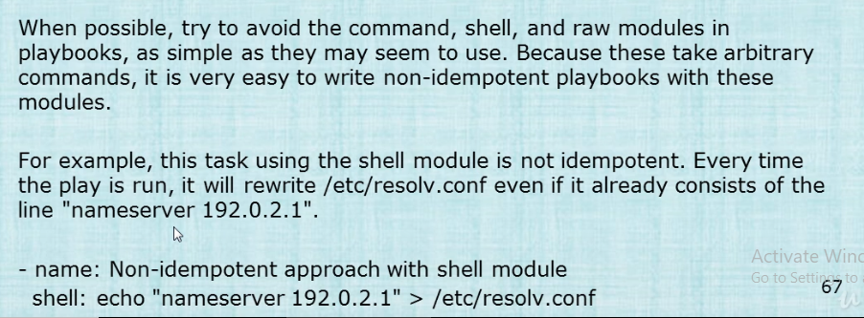

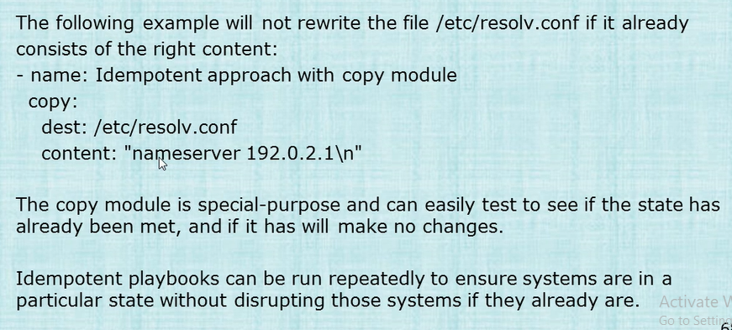

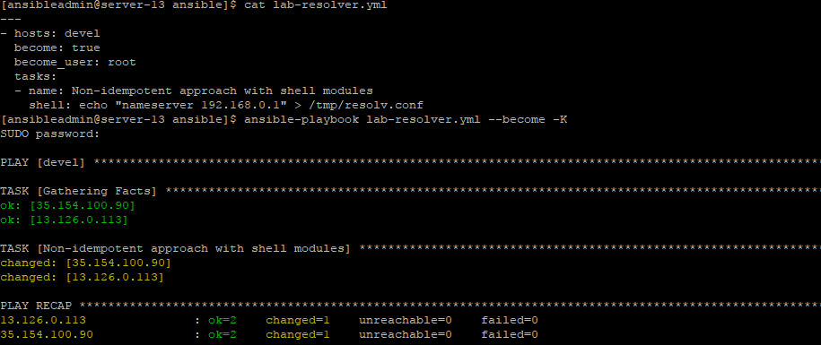

Running through shell will change the content again and again which reflects with the changed=1 value

Same with the copy module

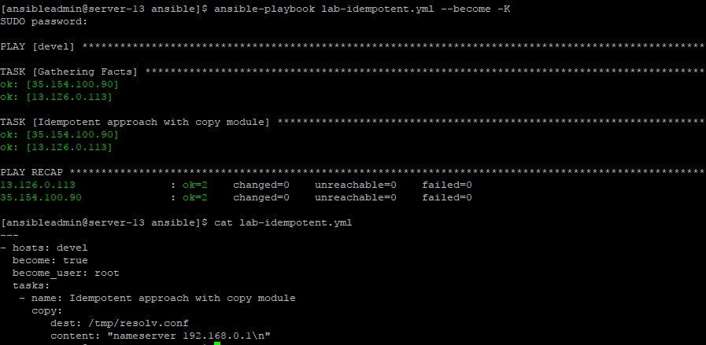

Installing and enabling multiple services at once:

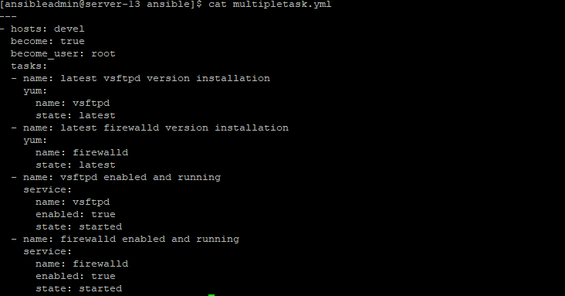

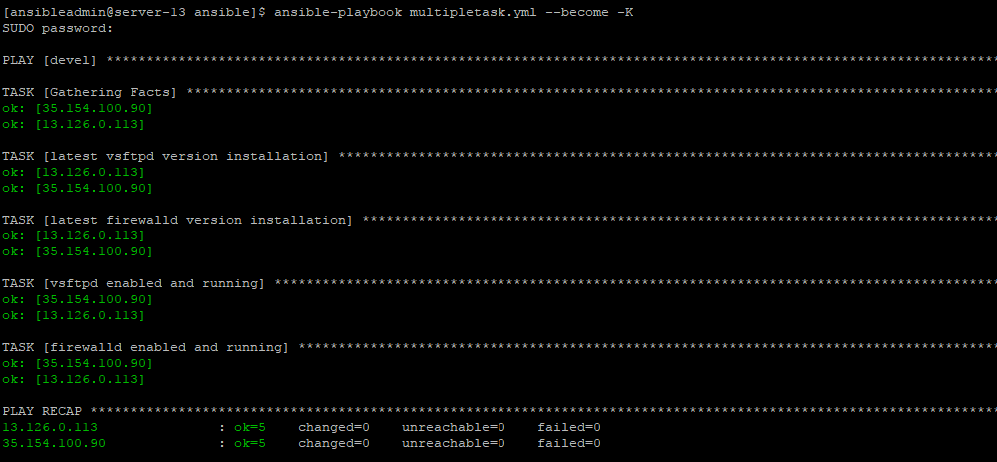

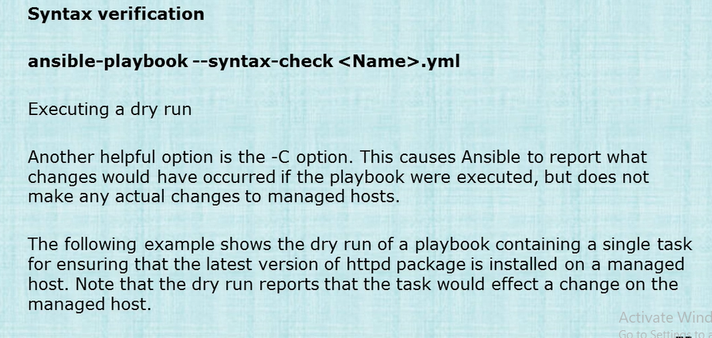

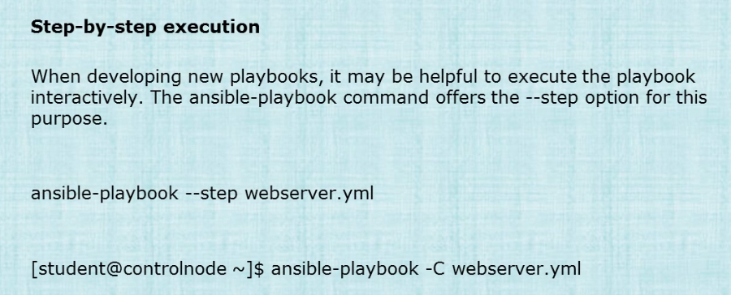

Installing apache with firewalld stopped

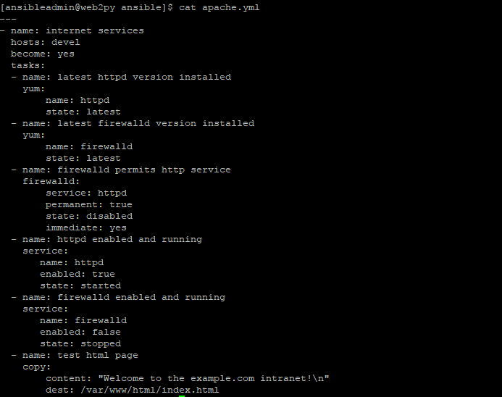



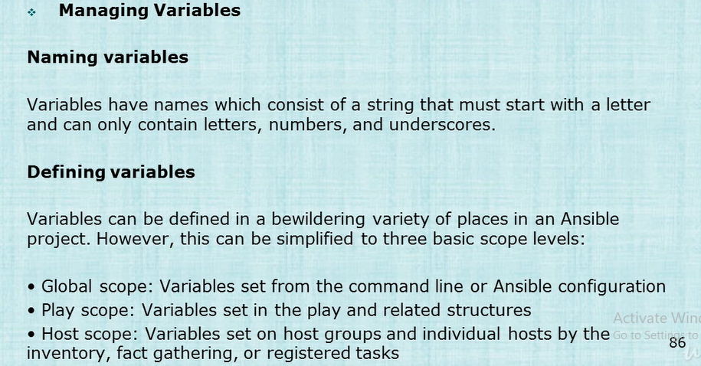

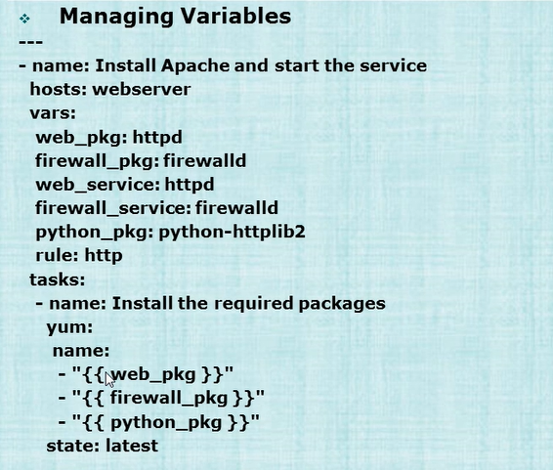

Firewalld Rules

- firewalld: service=https permanent=true state=enabled

- firewalld: port=8081/tcp permanent=true state=disabled

- firewalld: port=161-162/udp permanent=true state=enabled

- firewalld: zone=dmz service=http permanent=true state=enabled

- firewalld: rich_rule='rule service name="ftp" audit limit value="1/m" accept' permanent=true state=enabled

- firewalld: source='192.0.2.0/24' zone=internal state=enabled

- firewalld: zone=trusted interface=eth2 permanent=true state=enabled

- firewalld: masquerade=yes state=enabled permanent=true zone=dmz

The default location for the host inventory file is **/etc/ansible/hosts**. The **ansible\***

commands will use a different host inventory file when they are used with the **--inventory**

***PATHNAME*** option, **-i *PATHNAME*** for short.

Ansible host inventories can include groups of host groups. This is accomplished with the

**:children** suffix. The following example creates a new group, called **nwcapitols**, that

includes all of the hosts from the **olympia** and **salem** groups.

**[olympia]**

**washington1.example.com**

**washington2.example.com**

**[salem]**

**oregon01.example.com**

**oregon02.example.com**

**[nwcapitols:children]**

**olympia**

**salem**

Ranges match all the values between *START* and *END*, inclusive. Consider the following examples:

• **192.168.[4:7].[0:255]** - all IP addresses in the 192.168.4.0/22 network (192.168.4.0

through 192.168.7.255).

• **server[01:20].example.com** - all hosts named **server01.example.com** through

**server20.example.com**.

Managed hosts

Managed hosts do not need to have any special Ansible agent installed. They do need to have

Python 2, version 2.4 or later installed. If the version of Python installed on the managed host is

earlier than Python 2.5, then it must also have the *python-simplejson* package installed.

At times, it is desirable to use Ansible to manage systems that can not have Python

installed. Systems in this category, such as network routers, can be managed using

Ansible's **raw** module. Arguments passed to this module are run directly through the

configured remote shell instead of going through the module subsystem. However, in

most other cases the **raw** module should be avoided.

Wildcards

Another method of accomplishing the same thing as the **all** host pattern is to use the '**\***'

wildcard character, which matches any string. The following example shows how the '**\***' host

pattern can be used to reference all hosts defined in an inventory.

[student@controlnode ~]$ **ansible '*' --list-hosts**

hosts (6):

labhost1.example.com

test1.example.com

labhost2.example.com

test2.example.com

In contrast, when used in conjunction with the '**&**' character to separate groups in a host pattern,

the '**:&**' characters denote the intersections of two groups in the inventory. The following

example shows the use of a host pattern referencing hosts that are members of both the **lab**

and **datacenter1** groups.

[student@controlnode ~]$ **ansible 'lab:&datacenter1' -i myinventory --list-hosts**

hosts (1):

labhost1.example.com

listing hosts with exclusion using !



Another example



ansible all -m ping -u bruce -b --become-user batman

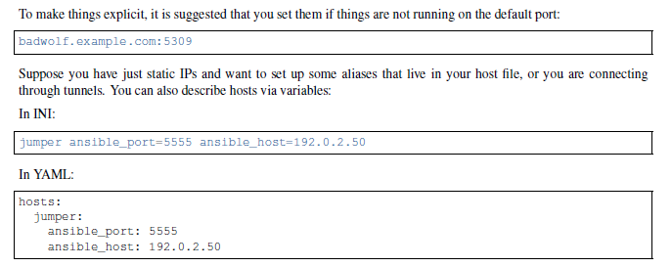

Any host that is member of a child group is automatically a member of the parent group.

• A child group’s variables will have higher precedence (override) a parent group’s variables.

• Groups can have multiple parents and children, but not circular relationships.

• Hosts can also be in multiple groups, but there will only be one instance of a host, merging the data from the

multiple groups.



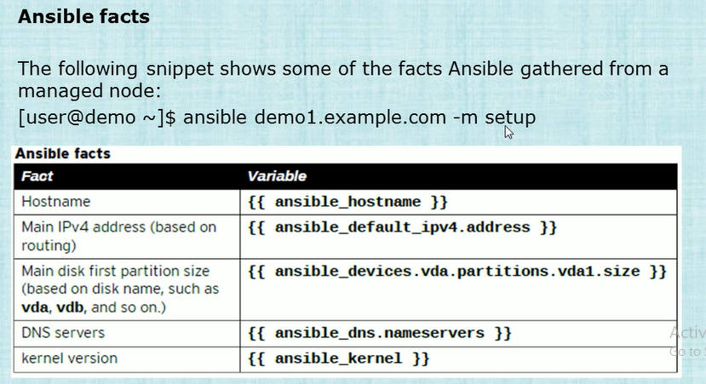

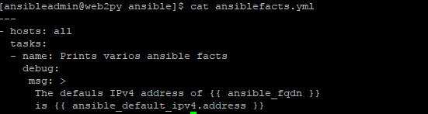

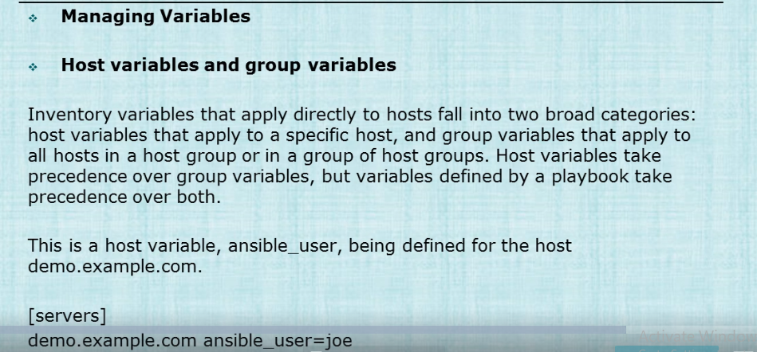

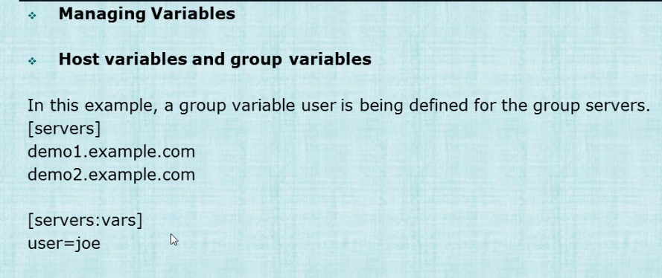

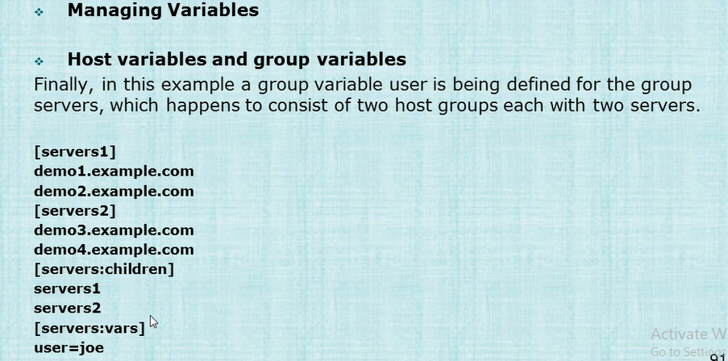

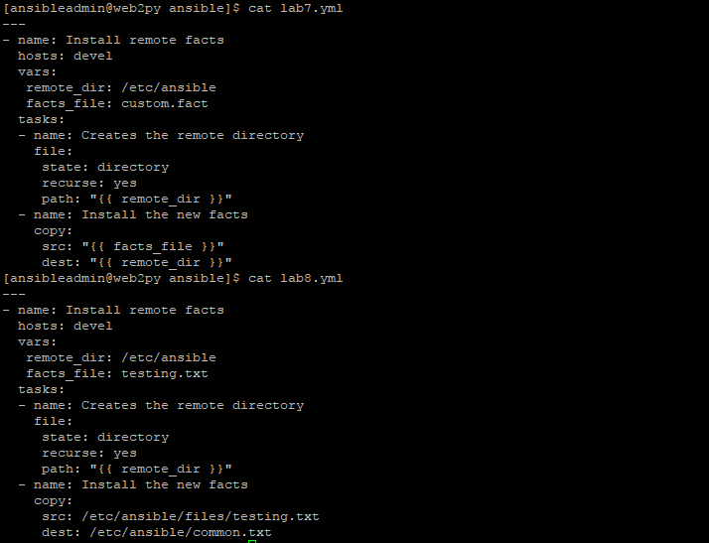

Default source path can be:-

/etc/ansible/files/

OR

/etc/ansible/

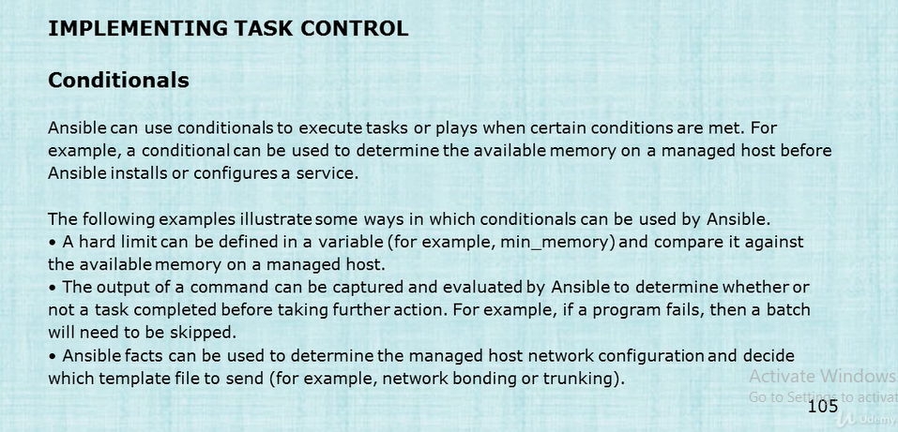

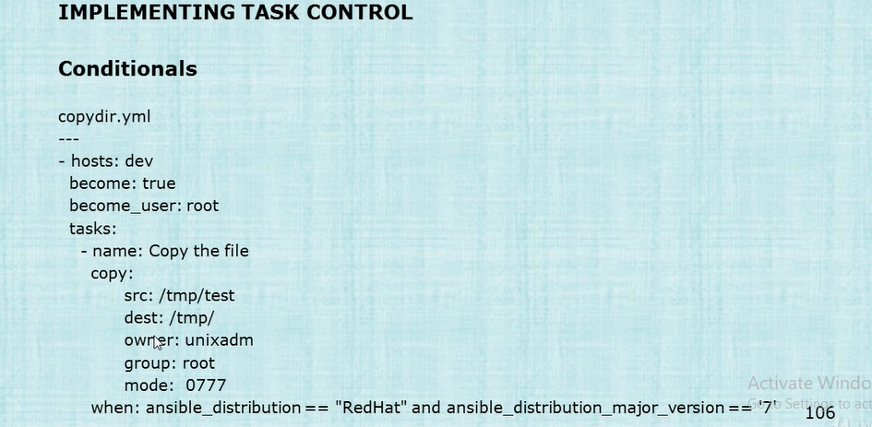

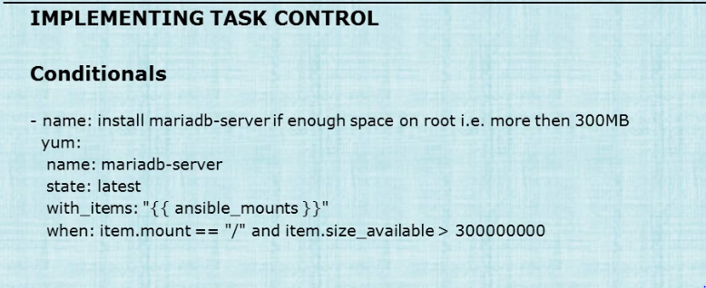

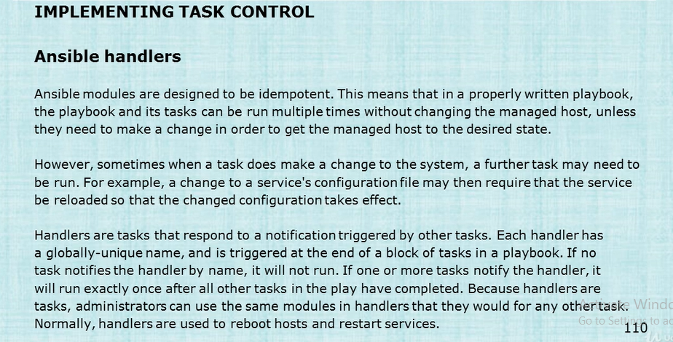

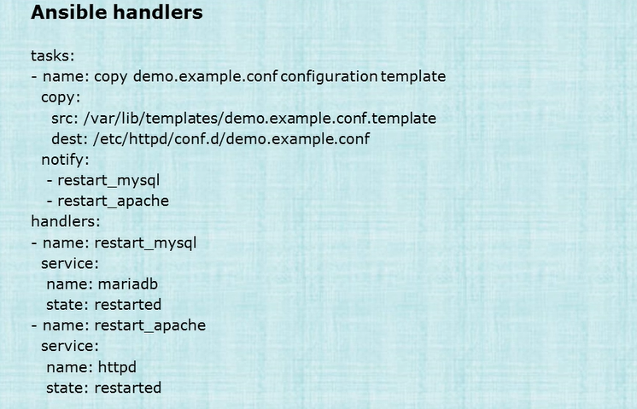

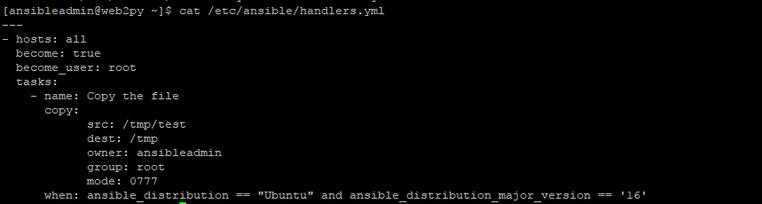



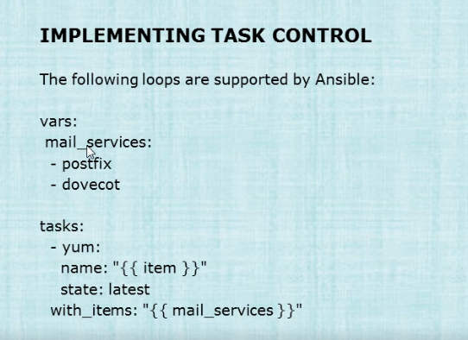

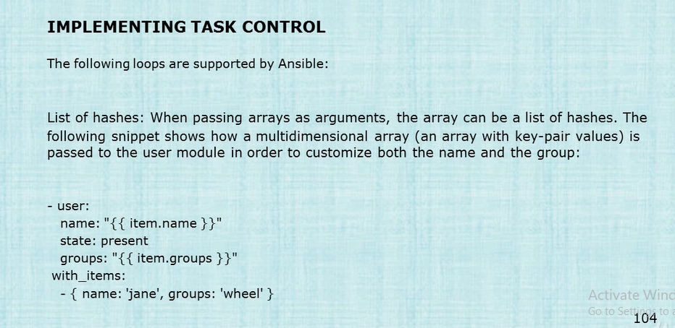

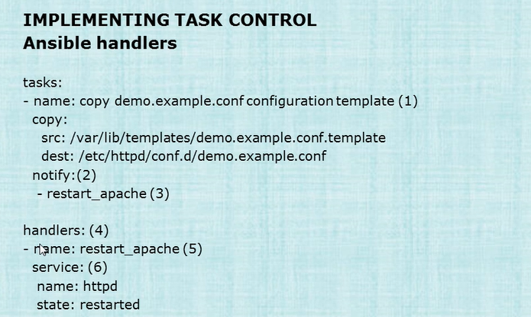

**Handlers :- How to use Handlers as below**

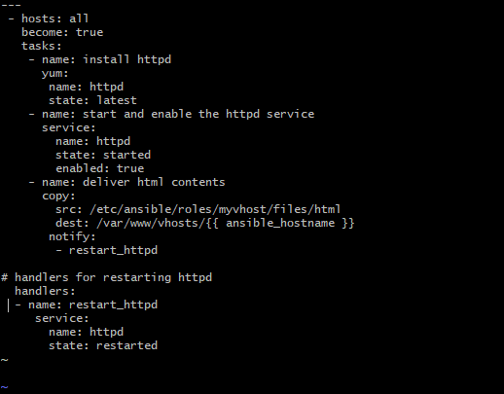

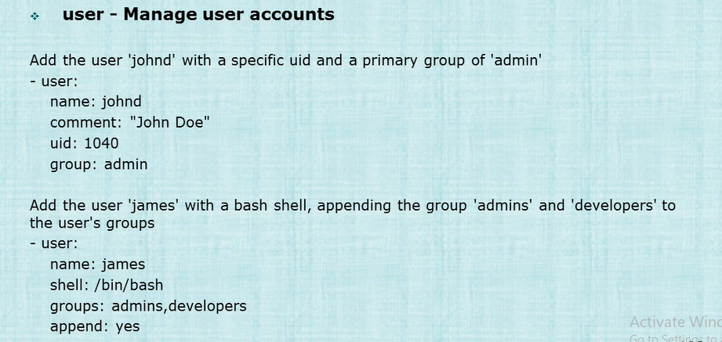

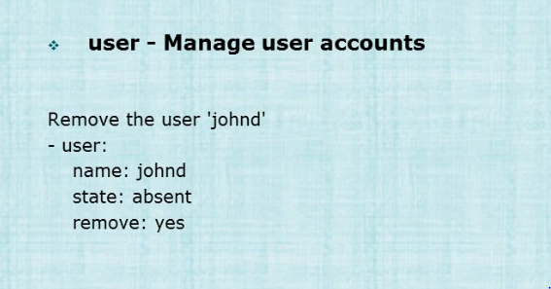

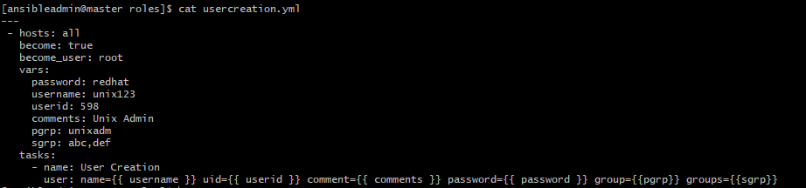

**Yaml is a set of key value pairs**

**To reboot the hosts**

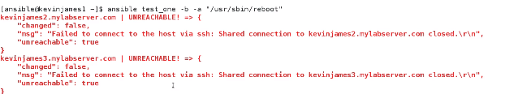

[ansible@master ansible]$ ansible all -a "ls -la /home/ansible"

[ansible@master ansible]$ ansible databases -b -a "less /var/log/messages"

[ansible@master ansible]$ ansible all -s -a "ls -l /root"



**-m stands for module**

[ansible@master ansible]$ ansible databases -b -m yum -a "name=elinks state=latest"

[ansible@master ansible]$ ansible databases -b -m yum -a "name=elinks state=absent"

[ansible@master ansible]$ ansible centos --list-hosts

**Suppose you have created your own file example myhosts then you can use -i switch to provide the filename**

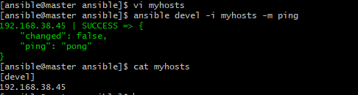

[ansible@master ansible]$ ansible devel -i myhosts -a "df -h"

**-m we have to put before the command starts**

[ansible@master ansible]$ ansible -i myhosts devel -b -m yum -a "name=elinks state=latest"

[ansible@master ansible]$ ansible devel -i myhosts -a "ls -l {{ folder }}"

localhost | SUCCESS | rc=0 >>

total 0

drwxrwxr-x. 2 ansible ansible 6 Jan 10 06:51 dir1

drwxrwxr-x. 2 ansible ansible 6 Jan 10 06:51 dir2

[ansible@master ansible]$ cat myhosts

[devel]

localhost folder=/home/ansible

**FORK controls how many hosts will run the adhoc command together if we have multiple hosts in the hosts file:-**

[ansible@master ansible]$ ansible all -a "ls -l" -f 100

192.168.38.47 | SUCCESS | rc=0 >>

total 0

localhost | SUCCESS | rc=0 >>

total 0

drwxrwxr-x. 2 ansible ansible 6 Jan 10 06:51 dir1

drwxrwxr-x. 2 ansible ansible 6 Jan 10 06:51 dir2

192.168.38.45 | SUCCESS | rc=0 >>

total 0

[ansible@master ansible]$ ansible databases -b -a "touch testfile" --become-user test

**The above will create testfile in test users home directory**

[ansible@master ansible]$ ansible databases -b -a "touch testfile1"

**The above will create testfile1 in ansibles home directory**

[ansible@master ansible]$ ansible databases -m copy -a "src=/etc/ansible/testfile9 dest=./testfile9"

[ansible@master ansible]$ ansible databases -b -m file -a "dest=/home/test/file123 mode=777" --become-user test

[ansible@master ansible]$ ansible databases -m file -a "dest=./file15 mode=600"

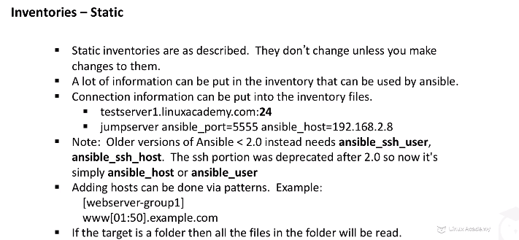

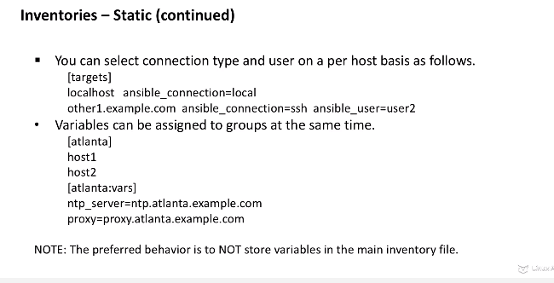

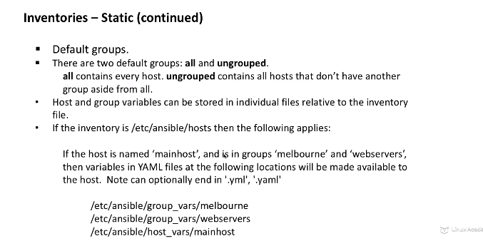

‘

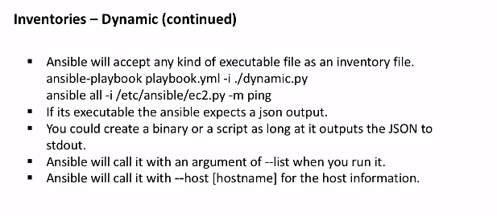

**Static Inventories**

[ansible@master static-hosts-example]$ ansible -i myhosts aws -a "ls -l /var/log/"

[ansible@master static-hosts-example]$ ansible-playbook -i myhosts test-playbook.yml

[ansible@master static-hosts-example]$ ansible -i myhosts all -a "hostname"

[ansible@master static-hosts-example]$ ansible -i myhosts aws -a "hostname"

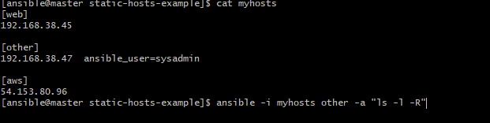

**Also uses paramiko for connectivity**

**How to install ansible from source**

10 mkdir ansibletemp

11 cd ansibletemp/

12 yum install git

13 git clone git://github.com/ansible/ansible.git --recursive

14 ll

15 cd ansible/

16 ll

17 cd bin/

18 ll

19 ./ansible (wont run as ansible needs to be compiled)

20 yum install gcc glibc (C compiler is needed)

21 cd ..

22 make

23 make install

24 which ansible

25 ansible --version

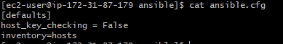

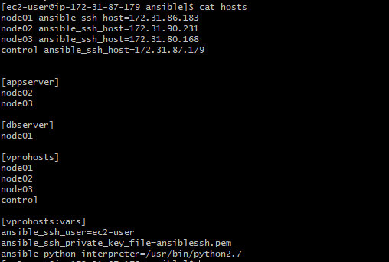

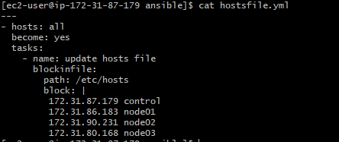

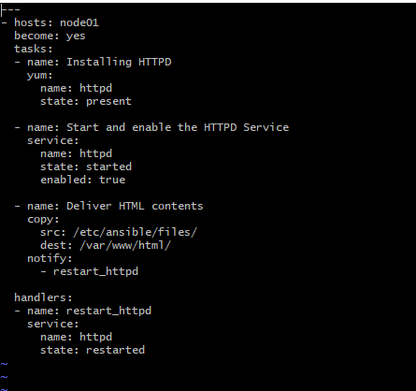

**WEB-DB Playbook**

---

- hosts: appserver

become: yes

tasks:

- name: Ensure apache is installed

yum:

name: httpd

state: present

- name: Copying files

copy:

src: /etc/ansible/files/

dest: /var/www/html mode0666

- name: Ensure Apache is running

service:

name: httpd

state: started

- hosts: dbserver

become: yes

tasks:

- name: Ensure MYSQL server is installed

yum:

name: mysql-server

state: present

- name: Ensure MySQL-python is installed

yum:

name: MySQL-python

state: present

- name: start MYsql

service:

name: mysqld

state: started

- name: Create Database

mysql_db:

name: accounts

state: present

- name: Create user Named mint

mysql_user:

name: mint

password: admin123

priv: '*.*:ALL'

state: present

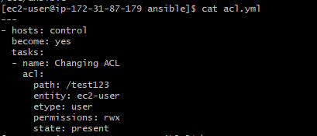

**USER CREATION:**

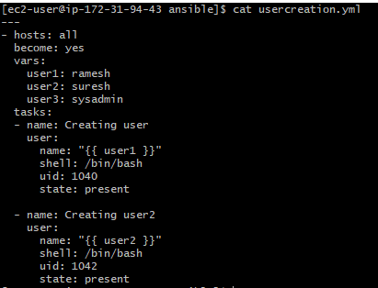

**Using variables with variable file**

